**Abstract**

**We present a scheme of how we can help drivers and provide a way to reduce car accidents. How Yolo can be improved to detect objects on thermal videos and how object detection results are used to predict the absolute distance between objects and the source camera.**

# Introduction

**1.1 Objectives**

Our project mainly is about object detection and distance estimation of vehicles using thermal imaging. We have seen a lot of car accidents happen a lot, especially on the roads with darkness or foggy weather.

We played the scene of the scenario. We have reached a satisfying result to solve this problem using thermal imaging and ML/DL technologies.

We have solved this problem by providing the driver with a video with all objects detected and info written and proved the accuracy of distance estimation on thermal imaging.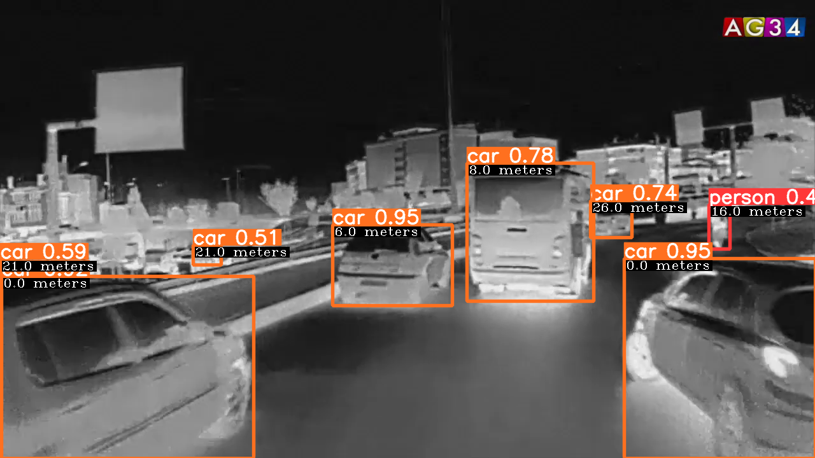

*Figure 1. Example of End Result.*

**1.2 Summary of Project Timeline**

* Phase A: Specifications & Setup
* Idea, competitive analysis, and, learning - are all about the idea evaluation, analysis, initial architecture, and technologies used.
* At that phase, we did a lot of searches and analyses to determine the project outline and take the initial steps to build the model, so it's all about choosing the optimal solution that helps in the point of the darkness and the foggy weather till evaluating the result of the competitive analysis depending on a specific metric.
* Phase B: Design
* At this phase, we had built initial abstract architecture to build an intuition about how the stuff is going, starting from processing inputs, calculating info needed to visualizing our results.
* Phase C: Development
* At this phase, we developed our custom object detector which detects vehicles on images or videos captured by a thermal camera, and distance estimation model which calculates the absolute distance between vehicles and the source camera using object detection results.
* Using thermal imaging we can have a clear video with all objects obvious regardless of the weather and visibility which is an extremely high advantage compared to normal imaging.
* The object detection model helps us detect vehicles & other objects and identify their type (e.g. car, bicycle, person, and so on) then determine the correct coordinates of these objects at each video frame.
* Then we use object detection results and with the help of the distance estimation model to determine the distance between the source camera and objects.
* At the end of this phase, we built a visualizer to write all this information back to the video frames so that the user can take a specific action based on the provided information.

# Available Solutions

**2.1  Detection and Distance Estimation using Normal Imaging**

* There is already a model that uses normal imaging to detect objects and estimate distance but in the presence of clouds and blurred vision here is the problem.
* This solution is based mainly on DL to detect moving vehicles in video streams and apply a distance estimation method to provide this info to the user.

**2.2  Arduino Ultrasonic Sensor**

* Estimates the distance only. But it can’t detect objects whose distance is more than 20m. And can’t detect objects which move at high speed.

***Summary***

| Solution | Pros | Cons |
| --- | --- | --- |
| Detection & Estimation using Normal Imaging. | Estimates distance. | Doesn’t work in unclear vision. |
| Arduino Ultrasonic Sensor | Works well regardless of vision.  Measures distance. | Can’t detect objects which distance farther than 70 feet and move at high speed. |

*Figure 2. Available Solutions Pros and Cons Summary.*

1. **Our Proposed Solution**

We provided a solution by using thermal imaging to estimate the distance of objects in bad weather and darkness.

We used the distance between detected objects and the vehicle which holds the thermal camera to provide some information to the driver and to take some action which in turn will reduce car accidents.

We collected a dataset of thermal images in foggy weather or unclear vision and retrain or build a new deep learning architecture based on the collected dataset to detect objects and estimate their distance.

1. **Development**

Before explaining every part in detail & what we have done. Let's take a look at the high-level conceptual arch of our system.

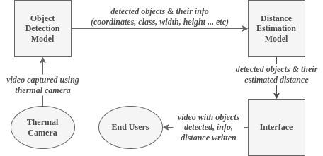

*Figure 3. Abstract Architecture.*

We developed a deep learning model to help us detect objects in thermal images/videos, identify their types/classes (e.g. car, person), and determine the coordinates of their locations.

Then we format detection results to match the distance estimation model and then use this formatted information afterward to estimate the object's distance.

Then we write this info back to the different video frames.

Subsequently, this process can be divided into 4 main parts:

* Object Detection
* Intermediate Results Calculation
* Distance Estimation
* Visualize Final Results

**1) Object detection**

**1.1 What is YOLO and why?**

YOLO, an acronym for 'You only look once, is an object detection algorithm that divides images into a grid system. Each cell in the grid is responsible for detecting objects within itself. It uses neural networks to provide real-time object detection so it’s popular because of its speed and accuracy.

YOLO algorithm employs convolutional neural networks (CNN) to detect objects in real-time. As the name suggests, the algorithm requires only a single forward propagation through a neural network to detect objects. In addition to High accuracy, it is a predictive technique that provides accurate results with minimal background errors.

This technique provides improved detection results compared to other object detection techniques such as Fast R-CNN and Retina-Net.

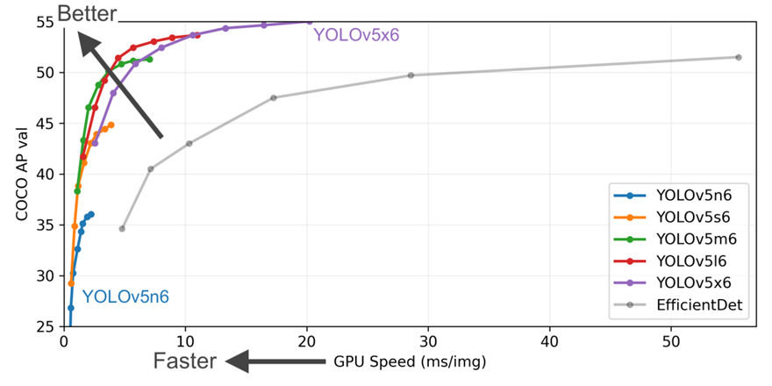

*Figure 4. Different YOLOV5 Models.*

It's always a trade-off of power vs performance. We trained a custom YOLO 5 object detection on our thermal dataset using pre-trained weights. First, we formatted our dataset to match the YOLO format.

Then, we train and test the model using different hyper parameters to get higher accuracy.

**1.2 Training YoloV5s**

**Download the thermal camera Dataset (FLIR Thermal Images Dataset)**

The FLIR Thermal Starter Dataset provides an annotated thermal image and non-annotated RGB image set for training and validation of object detection neural networks.

The dataset was acquired via an RGB and thermal camera mounted on a vehicle. The dataset contains a total of 14,452 annotated thermal images with 10,228 images sampled from short videos and 4,224 images from a continuous 144-second video.

All videos were taken on the streets and highways in Santa Barbara, California, the USA from November to May. Videos were taken under generally clear-sky conditions both day and night.

Human annotators labeled and put bounding boxes around 3 categories of objects. The MSCOCO label vector was used for class numbering.

•    Category 1:  People

•    Category 2:  Bicycles - bicycles and motorcycles (not consistent with coco)

•    Category 3:  Cars - personal vehicles and some small commercial vehicles.

For more details about the dataset ([**link**](https://www.kaggle.com/datasets/deepnewbie/flir-thermal-images-dataset)**).**

**Prepare dataset to match YOlO5 Format - Convert the Annotations into the YOLO v5 Format**

Export labels to YOLO format, with one *.txt file per image (if no objects in the image, no *.txt files are required).

The *.txt file specifications are

* One row per object.
* Each row is class x_center y_center width height format.
* Box coordinates must be normalized by the dimensions of the image (i.e. have values between 0 and 1).
* Class numbers are zero-indexed (start from 0).

**Prepare dataset to match YOlO5 Format - Organize Directories**

YOLOv5 locates labels automatically for each image by replacing the last instance of /images/ in each image path with /labels/. But first directories have to be in this format.

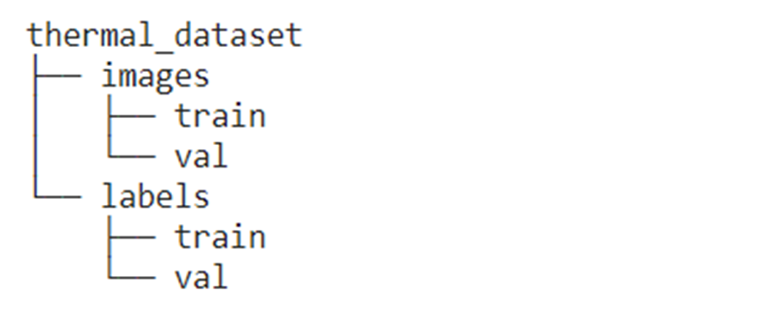

*Figure 5. FLIR Dataset Directory Structure.*

**Prepare dataset to match YOlO5 Format - Create the dataset YAML file**

Here we write a model configuration file for our custom object detector. We chose the smallest, fastest base model of YOLOv5.

The following parameters have to be defined in a data config file

1. Train, Test, and Val: Paths to train, test, and validation sets.
2. NC: Number of classes in the dataset.
3. Names: Names of the classes in the dataset. The index of the classes in this list would be used as an identifier for the class names in the code.

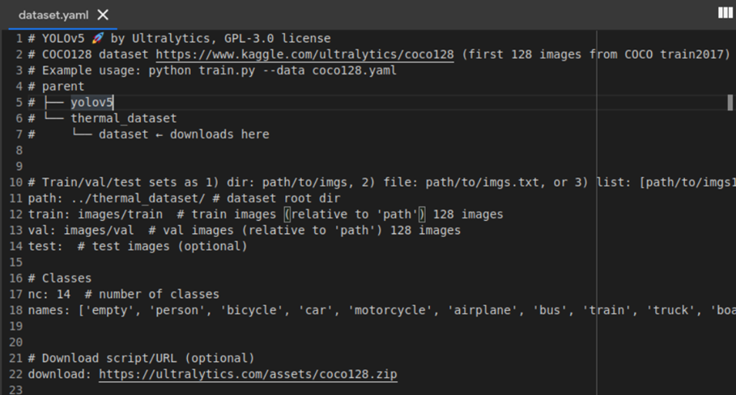

*Figure 6. Dataset YAML File Content.*

**Train a custom YOLOv5 detection model**

We chose the smallest, fastest base model of YOLOv5. Starting from pre-trained weight instead of randomly

initialized for better performance. Then, export saved YOLOv5 Weights for future use.

We train the model with different epochs (24, 50, and 70) to detect three objects: car, bicycle, and person.

**1.3 Evaluate Performance**

Now that we have completed training, we can evaluate how well the training process performed by looking at the validation metrics. The training script will drop output logs in “runs”.

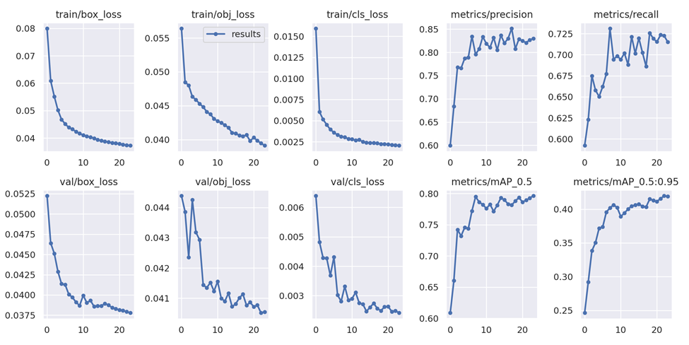

*Figure 7. Results of Train, Validation Sets for 24 Epochs.*

The more accurate results we get using 24 epochs but in the higher epochs size the model becomes “overfitted” and we can’t optimize it using data augmentation as the bounding boxes will change when the image flipped or rotated.

**1.4 Visualize YOLOv5 training data**

During training, the YOLOv5 training creates batches of training data. Here is a sample:

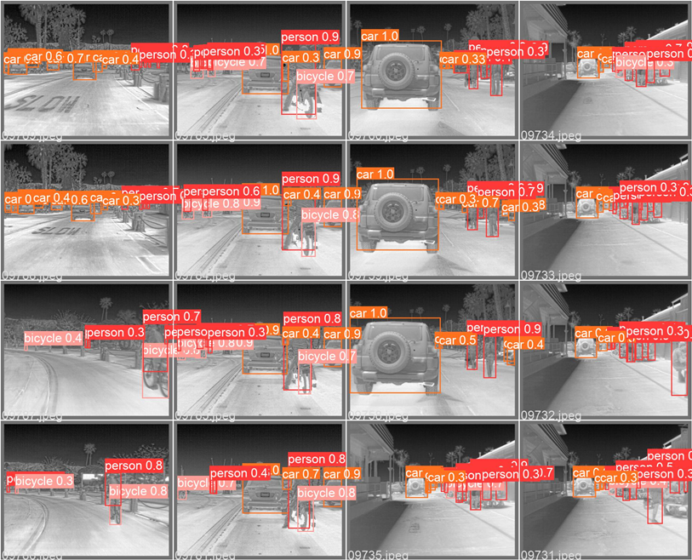

*Figure 8. Object Detection - Sample*

**1.5 Export YOLOv5 Weights for Future use**

Now our custom YOLOv5 object detector has been verified. We want to take the weights out for use in the coming detection tasks.

**2) Intermediate Results Calculation**

To estimate the distance to objects (cars, pedestrians, trucks) in the scene on the basis of detection information.

We modified the object detection model output format to output a generated sheet containing detected object coordinates.

The sheet has a row for each frame and a column with a coordinate (xmin, ymin, xmax, ymax).

We will use this sheet in the next step (distance estimation).

We also saved annotated video frames to write distance estimation results to them back later.

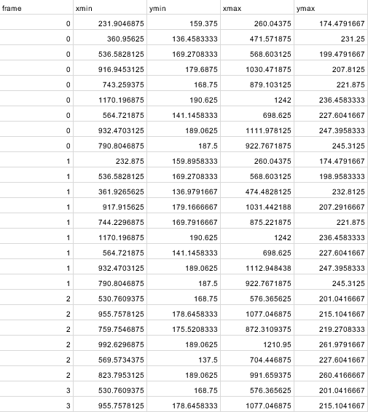

*Figure 9. Object Coordinates Sheet*

Edit detect.py in Yolov5 to extract the coordinate form (x_center,y_center, width, height) like that:

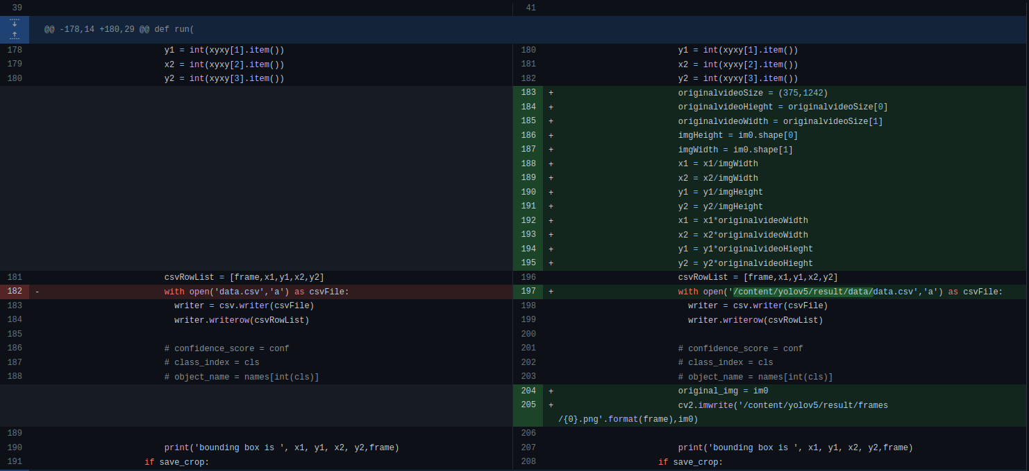

*Figure 10. detect.py Modifications*

**3) Distance Estimation**

Train a deep learning model that takes in bounding box coordinates of the detected object and estimates the distance to the object.

**3.1 Training**

**1. Download KITTI Dataset**

Kitti contains a suite of vision tasks built using an autonomous driving platform. The full benchmark contains many tasks such as stereo, optical flow, visual odometry, etc. This dataset contains the object detection dataset, including the monocular images and bounding boxes.

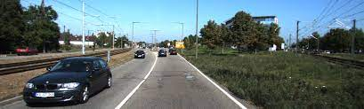

*Figure 11. Image Sample - Training Set*

**2. Format Dataset to match this directory structure**

KITTI Dataset  
 |-- test_images

|-- train_annots

`-- train_images

**3. Train Model**

We could train the model from scratch by basically running the train.py and passing train and test sets to it.

Or continue training a pre-trained model by running training_continuer.py and passing the pre-trained model, training weights, train, and test sets.

**3.2 Predicting**

We use bounding box coordinates (xmin, ymin, xmax, ymax) to predict distance (z).

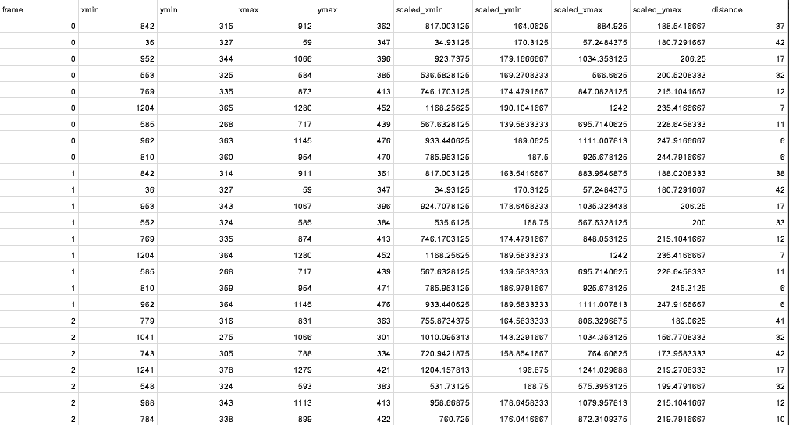

*Figure 12. Distance Estimation Output Example*

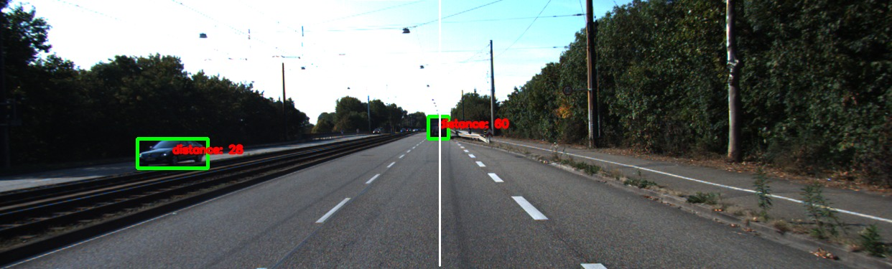*Figure 13. Distance Estimation Result*

**4) Visualize Final Results**

In this part, we wrote a basic visualizer to do the following two functions

1. Write all the estimated data to the video frames.
2. Generate the video from its frames to visualize the results.

*******Figure 14. Visualized Final Result Example*

**5- Conclusion**

In conclusion, we hope that we have clarified the problem faced by drivers, which is driving in bad weather, fog, lack of visibility, and many situations such as these. We hope our project to solve these problems using thermal imaging & ML/DL technologies.

We hope we can help drivers to see the road well regardless of vision problems, identify the surrounding vehicles, and determine the distance between them to

enable them to make the right decisions.

We hope our project will serve people in maintaining their safety, benefit them and reduce accidents caused by bad vision.

**6- References**

1. [FLIR Thermal Images Dataset](https://www.kaggle.com/datasets/deepnewbie/flir-thermal-images-dataset)
2. [KITTI Dataset](http://www.cvlibs.net/datasets/kitti/)
3. [Owl-to-join-the-thermal-imaging-fray](https://www.eetasia.com/owl-to-join-the-thermal-imaging-fray/)
4. [Arduino-Ultrasonic-Range-Finding-Sensor-for-20M-Distance-Measurement](https://www.piezohannas.com/Arduino-Ultrasonic-Range-Finding-Sensor-for-20M-Distance-Measurement-pd6643128.html)